Title | 4-wire top works modbus slave: Modbus Subsystem Software Design Description
Distribution | Software Archive
Author | Kunli.Zhou |  | Date | 2012-03-29
 | Zuochen Wang |  | Date | 2016-07-15
Review | Greg Leach |  | Date | 2012-04-15
 | Andrea Stelter |  | Date | 2013-01-22
 | Jax Yang |  | Date | 2013-03-19
 | Georg Horst |  | Date | 2016-06-15
Approved | Software Architect |  | Date
Approved | Project Leader |  | Date
Remarks | 2012-04-15 Reviewed by Greg Leach  2013-01-22 Reviewed by Andrea Stelter, modified by Spring Zhou  2013-03-19 Reviewed by Jax Yang, modified by Spring Zhou

© Copyright ABB 2013
This document contains information that is confidential. It must only be used for the agreed purpose for which it is provided. The contents of this document must not be reproduced or distributed in whole or in part without the written consent of ABB or its authorised representatives.

Contents
1 Context 3
1.1 Definitions, acronyms, and abbreviations 3
2 Data Sheet 4
3 Detailed Description 5
3.1 Static Modelling 5
3.1.1 Subsystem context 5
3.1.2 Subsystem structure 6
3.1.3 Class definition 7
3.2 Dynamic Modelling 8
3.3 Class Design 10
3.3.1 Hardwarelayer structure 10
3.4 Detailed Design 11
3.4.1 Initialize 11
3.4.2 Update Modbus 12
3.4.3 Update Modbus Communication Configuration 12
3.4.4 Request process 12
3.4.5 Data Handler of Modbus Common Component 13
3.4.6 Modbus Timers 14
3.4.7 Modbus PDU and Register definition 14
3.5 Design Decisions and Limitations 16
3.6 Hardware Dependencies 16
3.7 Data Object Description 16
3.8 References 16
4 Revision History 16
5 Design Review 16
5.1 Decision of the Review: 16
5.2 Check list: 17
5.3 Remarks: 17
5.4 Defects 17
5.5 Changes are proved: 17

Context
This Document is a representation of analysis, planning, implementation and decision-making. It consists of design information for the Modbus Slave Subsystem.

The document is divided into two main parts. Firstly there is the subsystem Data Sheet. This chapter lists important issues from a black-box view. Secondly there is a more detailed design description intended for developers who have to maintain or expand the subsystem.

Besides this document there are other documents that describe the requirements [1], test cases and the complete system the subsystem is used in. Links to those documents can be found at the end of the data sheet and in the references section.

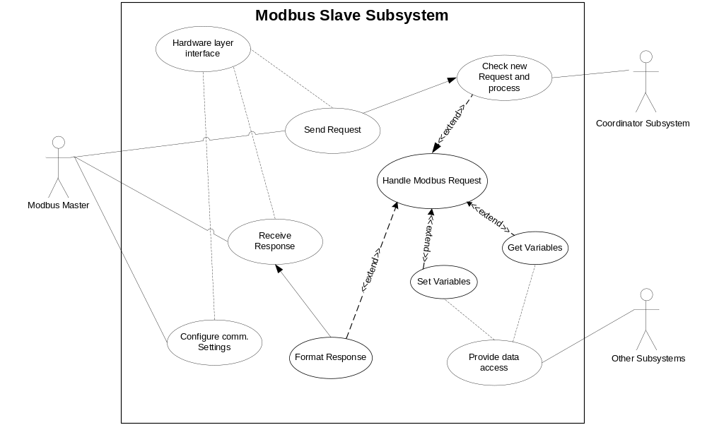
Figure 1: Use Case diagram for Modbus Subsystem

Definitions, acronyms, and abbreviations
 | Term |  | Definition
 | CRC |  | Cyclical Redundancy Checking
 | LRC |  | Longitudinal Redundancy Checking
 | PDU |  | Protocol Data Unit. The MODBUS application protocol defines a simple (PDU) independent of the underlying communication layers, including the Function code and data area.
 | RS485 |  | Standard for two wire half duplex serial binary data signal communication between two or more devices over balanced line twisted pair wire bus.
 | ARM Subsystem |  | A subsystem which will manage the access rights for different customer level
 | 4WCTW |  | 4 wire common top works
MB |  | Mother board
FBB |  | Daughter board

Data Sheet
Category | Item | Description
Development | Version / Status
Development | Known Bugs
Development | Planned Improvements
HW-Platform | Type | Renesas Rx210
HW-Platform | Clocking | 18.863MHz
SW-Development Environment | Compiler | IAR RX210 IAR C/CE Compiler Version V2.42.3 and IAR ELF Linker V2.42.2
SW-Development Environment | Operating System | EMBOS for RX210 Version 3.86e
SW-Development Environment | Case / Code-Generation Tool | Entry Tool 1.1.3  Modbus Gen Tool 1.0.9
Required Resources | Operating System | Subsystem signal semaphore
Required Resources | HW | RS485 UART, asynchronous half duplex  UART12, TXInterrupt, RXInterrupt  TMR2, Overflow Interrupt
Required Resources | RAM
Required Resources | NVRAM | Communication configurations parameter
Required Resources | ROM | Register table and command definition
Required Resources | Execution Time | <125ms
Required Resources | Special HW | None
Required Resources | Subsystems | All subsystem objects need to be configured in modbus register table
Required Resources | Data Objects
Standards | Safety
Standards | Other | - MODBUS APPLICATION PROTOCOL SPECIFICATION V1.1b3  - MODBUS over Serial Line Specification and Implementation Guide V1.02
Documentation | Requirements / Use Cases | See below Use Case diagram  4WCTW_Modbus Slave Subsystem Requirement Specification.doc
Documentation | Public Interface Description | UpdateEXE_MODBUS()
Documentation | Test Specification | See test plan

Detailed Description

Static Modelling

Subsystem context

The context of the Modbus Slave Subsystem is shown below in Figure 2 .

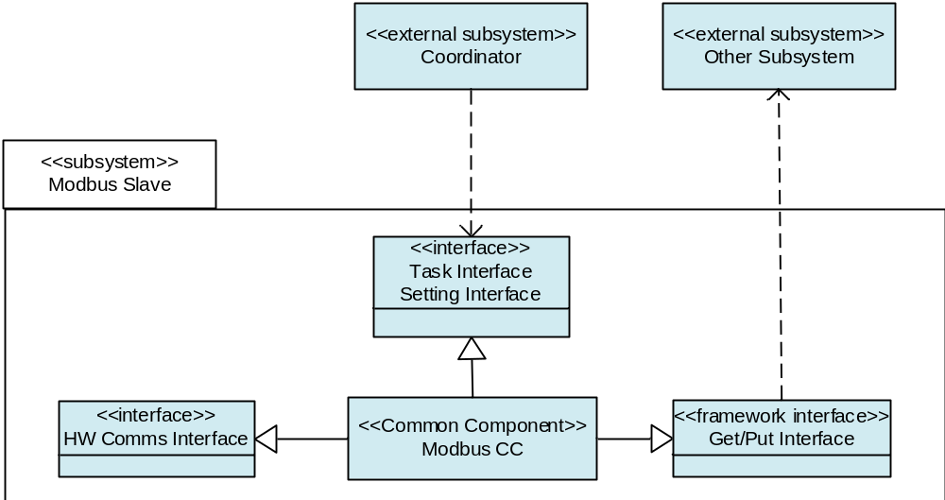
Figure 2 : Context diagram for Modbus Slave Subsystem

The entities are defined as follows:

<<external subsystem>> Coordinator
Plays as a coordinator in this project. It will call the task interface to trigger Modbus Slave subsystem processing the data.

<<external subsystem>> Other subsystem
Other subsystem having the objects that need to put and get through Modbus Slave subsystem.

<<interface>>HW Comms Interface
The communication will use UART 485 as hardware layer. Or USE I2C to communication with Optional MODBUS Module.

<<interface>> Task Interface
Provides an interface UpdateEXE_MODBUS (void) for Task Management to access Modbus Slave subsystem data process.

<<interface>>Setting Interface
Provides an interface UpdateModbusUartSettingEXE_MODBUS (void) for Task Management/Coordinator to Update the Modbus Communication Configuration.
Provides an interface UpdateScanRegister_MODBUS (void) for Task Management/Coordinator to Update the Modbus Scan Registers Table.

<<framework interface>> Get/Put Interface
This interface is the common interface of framework, it realize the relationship between the Modbus Slave subsystem to other subsystem objects set and get.

Subsystem structure
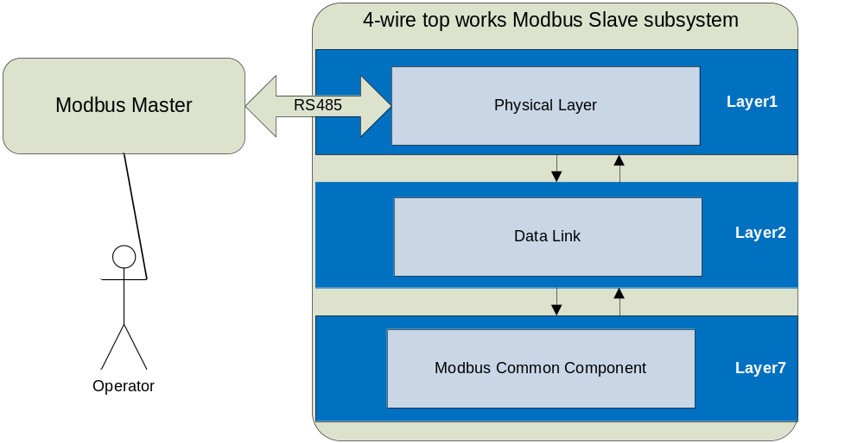
Figure 3 : Modbus Slave Subsystem structure Diagram

Class definition
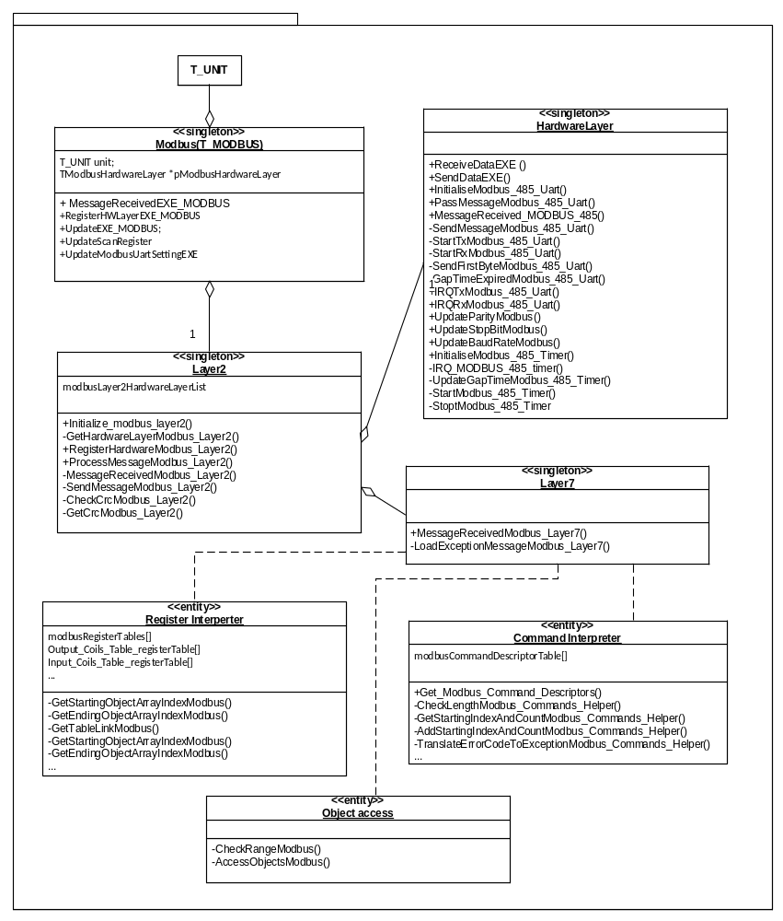
Figure 4: Modbus Slave Subsystem class Diagram

Dynamic Modelling
The following three figures show the state chart and activity chart of modbus slave subsystem transmission and data process.

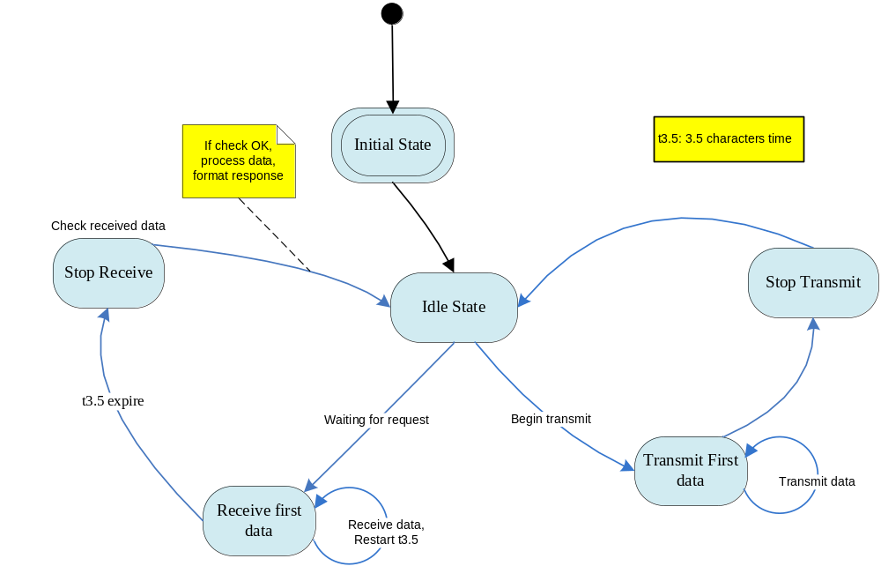
Figure 5: State chart of RTU transmission and timers

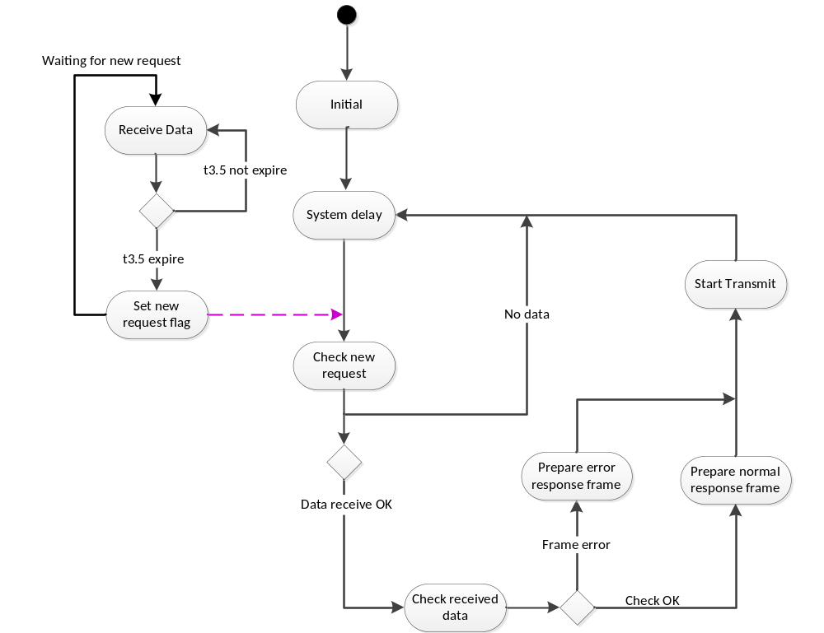

Figure 6: activity diagram of RTU transmission

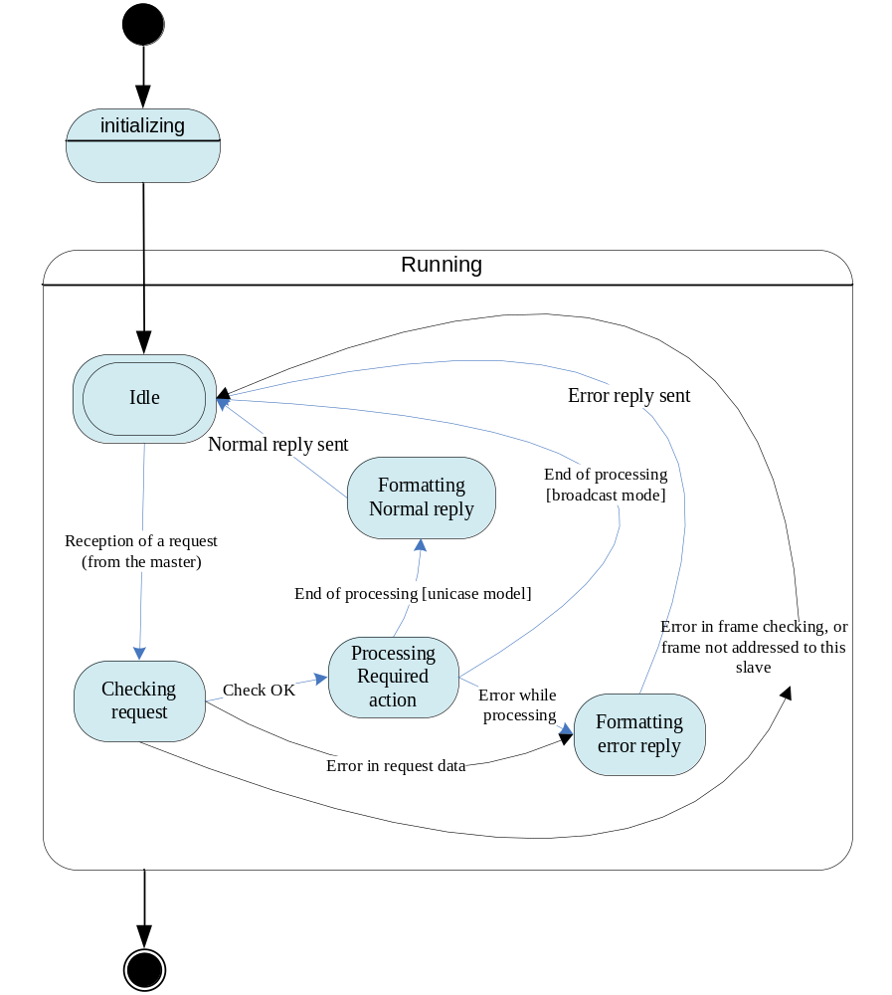
Figure 7: State chart of Data Process

Class Design

Hardwarelayer structure

The subsystem put all the related hardware parameters and buffers to one whole structure TModbusHardwareLayer.

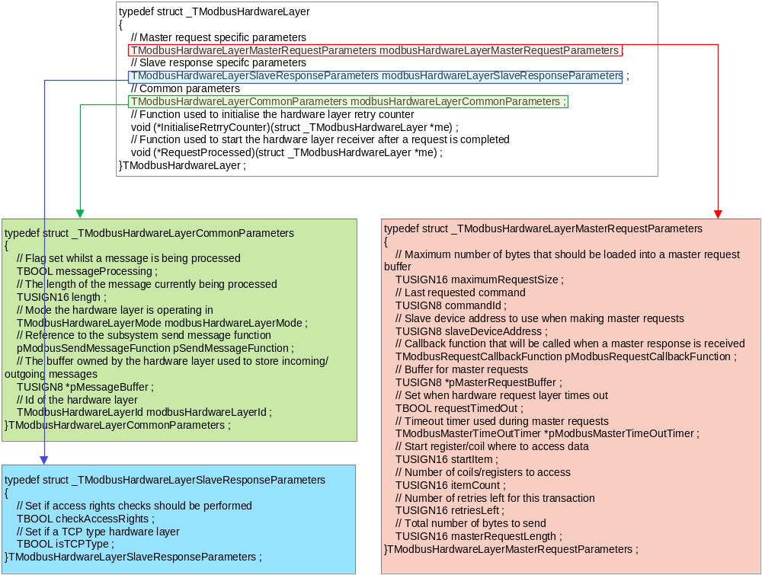

_TModbusHardwareLayer
This structure includes all the hardware layer related issues, including following three structure.

_TModbusHardwareLayerMasterRequestParameters
This structure lists all the parameters of the master request.

_TmodbusHardwareLayerSlaveResponseParameters
This structure lists the parameters of the slave response

_TmodbusHardwareLayerCommonParameters
This structure lists all the parameters related to communications. Including the SendResponseFunction pointer and the receive/transmit buffer pointer.

Detailed Design

Initialize

hardware layer related parameter
Define the modbusLayer2HardwareLayerList in layer2. For 4-wire top works Modbus Slave subsystem, only one uart 485 is implemented.
Define the TModbusHardwareLayer modbus485HardwareLayer sturcture initial value.

Initialize hardware layer
The Modbus Hardwarelayer should be initialized including the UART and timer initialization. The elements should be initialized are listed here: transmission mode, slave address, baud-rate, parity and stop-bit. Gap time.
Register the hardware layer by using the method RegisterHWLayerEXE( ), ensure the hardware layer is not used by other port (this is not compulsory for only one hardware layer will be inplemented).

Update Modbus
In the main task, the modbus subsystem will check if the hardware layer have received request data, if there is a complete frame received, then use the ProcessMessageModbus_Layer2( ) method to process the request.
After processing data and format response, use SendMessageModbus_Layer2 ( ) method to send the response frame.

The activity diagram takes reference to Fig 5.

Update Modbus Communication Configuration
When the configuration of the modbus is changed, the modbus slave subsystem will update the settings using the following functions.
- UpdateModbusUartSettingEXE ()
This function will change the Modbus UART Setting. It includes:
- Address->Default Setting Value is one.
- BaudRate->Default Setting Value is 9600 bps.
- Parity->Default Setting Value is ODD
- StopBits->Default Setting Value is one stop bit.
- ResponseDelayTime->Default Setting Value is 10 ms.

- UpdateScanRegister ()
This function is going to update the snap view of registers. The snap view is a collection to collect the values in in different registers address.
At the same time, update the Gap time settings according to these changes.

Request process
The request activity is processed by common component subsystem, see diagram below.

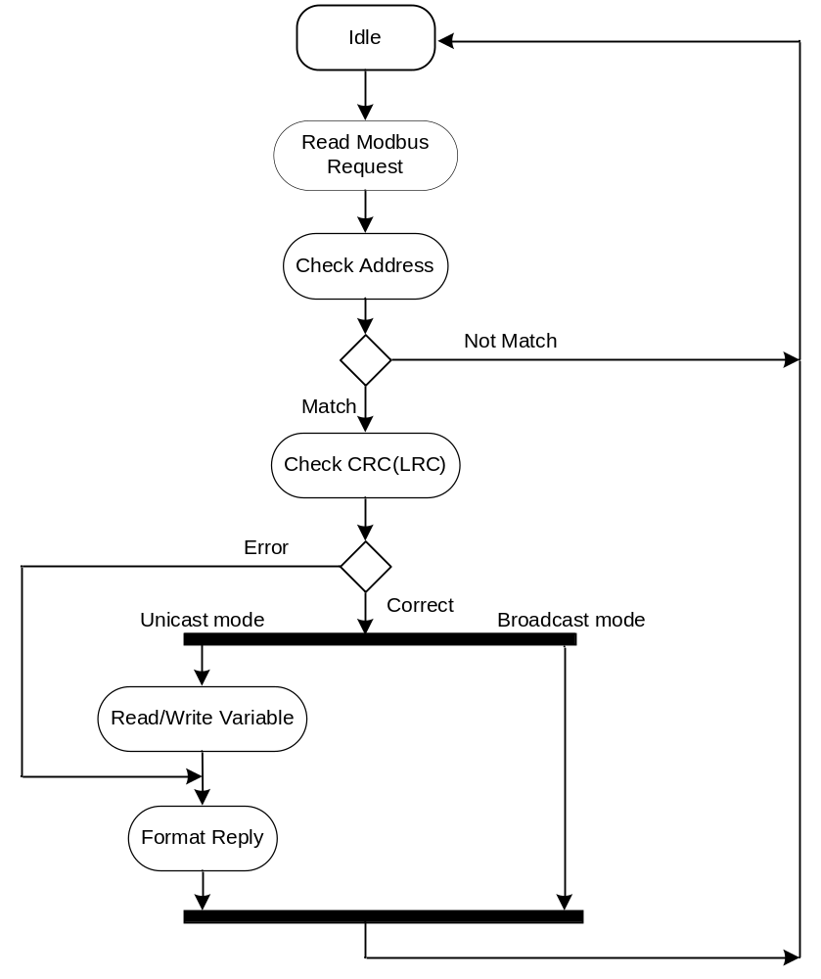
Figure 8: Flow chart for request process

Data Handler of Modbus Common Component

The figure below gives a brief introduction about the data process activity, detailed information please see Common component subsystem design description.
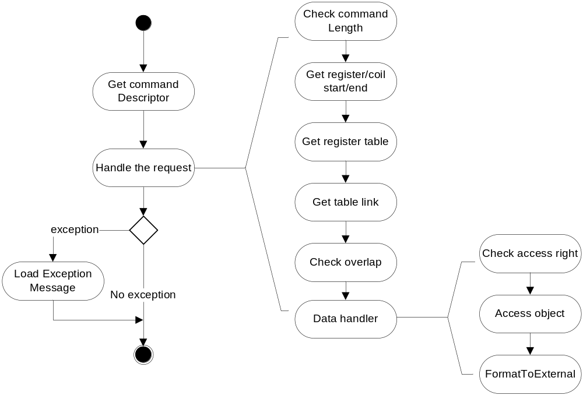
Figure 9: Activity diagram for request process

Modbus Timers

Inter frame timer
If the baud rate is higher or equal to 38400bps, then the inter frame timer should fix at 1.75ms.
The interframe time will be updated when the communication configuration variables changes.
If the inter frame timer overflows when receiving data, it will consider that this frame is over and pass the data to layer2.

Inter character timer
Do not implement this timer in the subsystem, it is ensured by the modbus master.

Modbus PDU and Register definition
Modbus Serial Line PDU is the data object passed between Remote Comms subsystem and Modbus Stack Interface. In reality, a pointer is used to point to the head of this PDU buffer, when we pass it, we just change the pointer. It’s a common useful method of data transfer. The same method is used in Modbus PDU which is transferred between Modbus Stack Interface and Modbus Slave Stack.

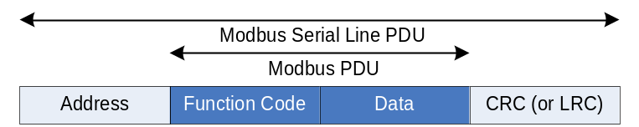
Figure 10: Modbus frame format

- Modbus Addressing rules
The Modbus addressing space comprises 256 different addresses. Number 1~247 can be used for this Modbus Slave. NV Default shall be 247.
The Address 0 is reserved as the broadcast address. All slave nodes must recognise the broadcast address. The slave nodes must have an address. This address must be unique on a MODBUS serial bus.

- The standard command supported are shown in table below.

Command ID (Hex) | Description
0x1 | Read coils
0x2 | Read discrete inputs
0x3 | Read holding registers
0x4 | Read input registers
0x5 | Write single coil
0x6 | Write single register
0x8 | Diagnostics
0xF | Write multiple coils
0x10 | Write multiple registers
0x11 | Report slave id
Table 1: Standard Modbus commands
The sub-command ids shown in Table should be supported by the Diagnostics command (0x8).

Sub-command ID (Hex) | Description
0x0 | Return query data
Table 2: Supported Diagnostics command sub-ids

- Data field
Commonly, the Data field includes the register addresses and the number of registers or the preset values.
Table 4 is the index table that we can use to map the Modbus registers to the variables. As described in the requirements document, the uppermost level register structure is provided shown in Table 4 below.

Custom Command Address | Device Address | Description
0 .. 09999 | 1 .. 10000 | Coils (outputs)
10000 .. 19999 | 10001..20000 | Input coils
30000 .. 39999 | 30001.. 40000 | Input registers
40000 .. 49999 | 40001.. 50000 | Holding registers
Table 3: Modbus Subsystem register table structure

- CRC Check
CRC is used for RTU mode
CRC calculation is implemented in two use-cases: “checking request” after the reception of the request and “formatting reply” after the end of processing.
For CRC, we use the Index table method, the generating polynominal = 1 + x2 + x15 + x16. The two 256B tables reside in ROM.

Communication to Option Card Modbus
4WCTW MB communicate with FBB via I2C interface, the 4WCTW MB is I2C master, Modbus module is I2C slave.
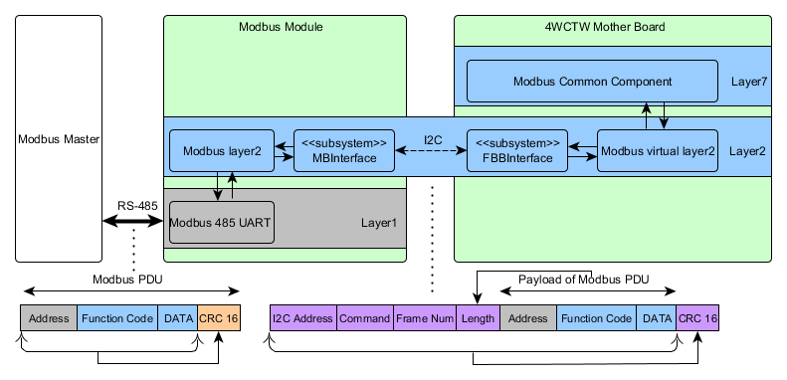

Figure 11: MODBUDS Deployment Diagram
An event-driven task FBBITask to drive the communication between the MODUBS module and 4WCTW mother board Modbus. Task shall drive/call CommunicationCtrlModbus of FBBInterfaceto interact with MODBUS.

Design Decisions and Limitations

Hardware Dependencies
This Modbus Slave Subsystem is developed on the Renesas Rx210 microcontroller, use UART12 as it communication hardware and user timer MTU5 to manage the inter frame time.
Power control of this hardware is handled outside the scope of the Modbus Subsystem.
If it work together with FBBInterface. Then the RIIC is used to communicate with optional MODBUS module.

Data Object Description

Data Object Type Description

t_data_obj_modbus_diag.c
The data class comply with ABB Framework. It inherit from t_data_obj class. The follow two functions are overload by t_data_obj_modbus_diag.

Put_MODBUS_DIAG
TUSIGN16 Put_MODBUS_DIAG(const T_DATA_OBJ SLOW*me,
void FAST* ptrValue,
TINT16 attributeIndex,
OS_RSEMA FAST* ptrDataSemaphore)

This method blocks any put request, as the diagnostic bytes are read only, write request is not acceptable.
Any calling of this function will received a READ_ONLY_ERR result.

Parameters:
ptrValue ->the new object or attribute value;
attributeIndex-> Set to -1 to operate on the whole object. Set the value above -1 will locate a specify attribute.
ptrDataSemaphore-> Pointer to the resource-semaphore of the used data-memory

Get_MODBUS_DIAG
TUSIGN16 Get_MODBUS_DIAG(const T_DATA_OBJ SLOW*me,
void FAST* ptrValue,
TINT16 attributeIndex,
OS_RSEMA FAST* ptrDataSemaphore)

This method extracts the active diagnostic alarm information from diagnostic sub-system, and stored the value in ptrValue to pass it to the external interface.

Parameters:
ptrValue -> the new object or attribute value will be returned in ptrValue
attributeIndex-> Set to -1 to operate on the whole object. Set the value above -1 will locate a specify attribute.
ptrDataSemaphore-> Pointer to the resource-semaphore of the used data-memory
The return value will be OK or ILLEGAL_ATTRIB_IDX according the operate result.

t_data_obj_modbus_diag_history.c
The data class comply with ABB Framework. It inherit from t_data_obj class. The follow two functions are overload by t_data_obj_modbus_diag.

Put_MODBUS_DIAG_HIS
TUSIGN16 Put_MODBUS_DIAG_HIS(const T_DATA_OBJ SLOW*me,
void FAST* ptrValue,
TINT16 attributeIndex,
OS_RSEMA FAST* ptrDataSemaphore)

This method blocks any put request, as the diagnostic history bytes are read only, write request is not acceptable.Any calling of this function will received a READ_ONLY_ERR result.

Parameters:
ptrValue ->the new object or attribute value;
attributeIndex-> Set to -1 to operate on the whole object. Set the value above -1 will locate a specify attribute.
ptrDataSemaphore-> Pointer to the resource-semaphore of the used data-memory

Get_MODBUS_DIAG_HIS
TUSIGN16 Get_MODBUS_DIAG_HIS(const T_DATA_OBJ SLOW*me,
void FAST* ptrValue,
TINT16 attributeIndex,
OS_RSEMA FAST* ptrDataSemaphore)

This method extracts the alarm history information from diagnostic sub-system, and return these values to the caller.

Parameters:
ptrValue -> the new object or attribute value will be returned in ptrValue
attributeIndex-> Set to -1 to operate on the whole object. Set the value above -1 will locate a specify attribute.
ptrDataSemaphore-> Pointer to the resource-semaphore of the used data-memory
The return value will be OK or ILLEGAL_ATTRIB_IDX according the operate result.

References
Ref. | Document
[1] | 4-wire top works Modbus Subsystem Requirements Specification
[2] | Modbus common component design description
[3] | 4WCTW Comport design description
[4] | Modbus_Application_Protocol_V1_1b.pdf
[5] | Modbus Over Serial Line V1.02
[6] | V0.9_4WCTW Mother Board and Field Bus Board Protocol.docx
[7] | 4WCTW Fieldbus Module Firmware Integration Guide.doc
[8] | V0.2_4WCTW Modbus Module System Design Description.docx

Revision History
Rev. | Description of Version/Changes | Primary Author(s) | Date
0.1 | Initial revision | Spring Kunli.Zhou | 2012-02-10
0.2 | Modification to design according to requirements and guidance under Greg Leach | Spring Kunli.Zhou | 2012-04-15
1.0 | Do not use Comport subsystem as the communication interface, the subsystem will use the hardware UART and timer directly. | Spring Kunli.Zhou | 2013-01-17
1.1 | Modified after review by Andrea Stelter | Spring Kunli.Zhou | 2013-01-23
1.2 | Modified after review by Jax Yang | Spring Kunli.Zhou | 2013-03-19
1.3 | Modified according to the reviewed comments under Georg Horst | ZuoChen Wang | 2016-07-15

Design Review

Decision of the Review:
 | Decision | next steps
q | Inspection passed without restrictions | Phase finished
q | Inspection passed with restrictions | some changes must be done
q | Inspection not passed | Inspection must be repeated

Check list:
 |  | yes | no
1. | Is the software architecture distinct and documented? | Y
2. | Fit the modules together? | Y
3. | Are complex algorithms/procedures explained? | Y
4. | Is a strategy for error handling designated? | Y
5. | Is the configuration management system well prepared? | Y
6. | Are all open issues transferred to the defects table? | Y

Remarks:

Defects
No. | Checkpoint | Description | Major  defect | done  Date
1 | 3.2 | Do not need to implement the inter-character timer. Change the dynamic diagram | N | 2012-4-15
2 | 3.2,3.4.4.1 | Only need to use Read () function to get the communication data, do not need to process the timeover which will be implemented in the comport subsystem. Change the description and the diagram. | N | 2012-4-15
3 |  | Delete all the customized command definition, common command 0x8 only support one subcommand. | N | 2012-4-15
4 | 3.4.6.1 | ‘If the baud rate is higher than 38400bps’ should change to ‘If the baud rate is higher than or equal to 38400bps’ |  | 2013-1-22
5 | 3.4.8 | “two 256B tables reside in EPPROM” should be “ROM” | N | 2013-1-22
6 | 3.2 | Figure 6: activity diagram of RTU transmission.  “Set new request flag” should be connected to the entry before the “Check new request ” block. | N | 2013-3-19
7 | 3.4.7 | The abbreviation “PDU” need to be explained in details. | N | 2013-3-19
8 | 3.4.8 | Section “(4)CRC Check”  The CRC polynomial should be specified. | N | 2013-3-19
9 | 4 | Under Data Sheet (2):  - SW-Development Environment to be extended by IAR RX210 IAR C/CE Compiler Version V2.42.3 and IAR ELF Linker V2.42.2  - Operating System extend by embOS for RX210 Version 3.86e | N | 2016-06-15
10 | 4 | Scan Registers are not described in the Design Spec. | Y | 2016-06-15
11 | 4 | Update Modbus Uart Settings are not described in the Design Spec. | Y | 2016-06-15
12 | Other | Under Acronyms and Abbreviations (1.3): No 4-wire related definitions. | N | 2016-06-15
13 | Other | Interface to Option Card Modbus is missing as rough description and as reference. | Y | 2016-06-15
14 | Other | Detailed description of t_data_obj_modbus_diag & t_data_obj_modbus_diag_history missing | N | 2016-06-15

Changes are proved:
The Reviewer confirms that all changes are done:
Proved Rev: | Updated to Rev: | Date: | Reviewer:
Spring Zhou | 0.2 | 2012-4-15 | Greg Leach
Spring Zhou | 1.1 | 2013-1-23 | Andrea Stelter
Spring Zhou | 1.2 | 2013-3-19 | Jax Yang

